Game Design Document

Fill up the following document

1. Write the title of your project.

Need For Fire Multiplayer Shooting game (NFF)..

1. What is the goal of the game?

To shoot the enemies.

1. Write a brief story of your game

To create a multiplayer shooting game with interesting rewards

1. Which are the playing characters of this game?

* Playing characters are the ones who respond to the user based on the input from the user.
* Cars, monkeys, dinos, wizards, etc., are the playing characters in the game.

|  |  |  |
| --- | --- | --- |
| Number | Character Name | What can this character do? |
| 1 | Contra | To over come obstacles and enimies |
| 2 |  |  |
| 3 |  |  |
| 4 |  |  |
| 5 |  |  |
| 6 |  |  |
| 7 |  |  |
| 8 |  |  |

1. Which are the Non-Playing Characters of this game?

* Non-Playing characters are the ones that don't have an action or behavior when the user interacts with the game.
* Hurdles, stones, bananas, coins, etc., are non-playing characters in the game.

|  |  |  |
| --- | --- | --- |
| Number | Character Name | What can this character do? |
| 1 | Zombie | To shoot the playing characters |
| 2 | eleins | To shoot the playing characters |
| 3 |  |  |
| 4 |  |  |
| 5 |  |  |
| 6 |  |  |
| 7 |  |  |
| 8 |  |  |

Draw your imagination of this game. What does this game look like?

* Draw the game either on your computer or on paper.
* Add images of the game scenes to show each of the playing and non-playing characters at least once.

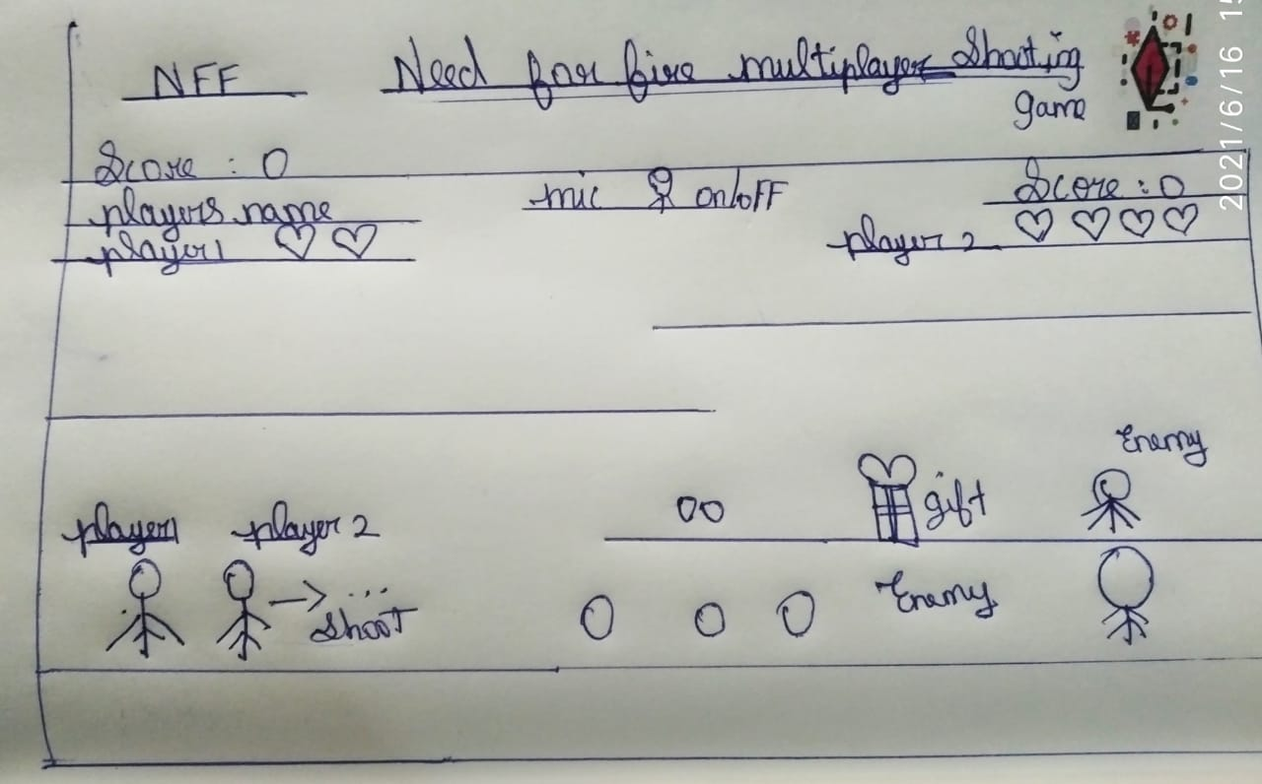

How do you plan to make your game engaging?

As the game progress planing to powerup obstacles and need to choose their own background.